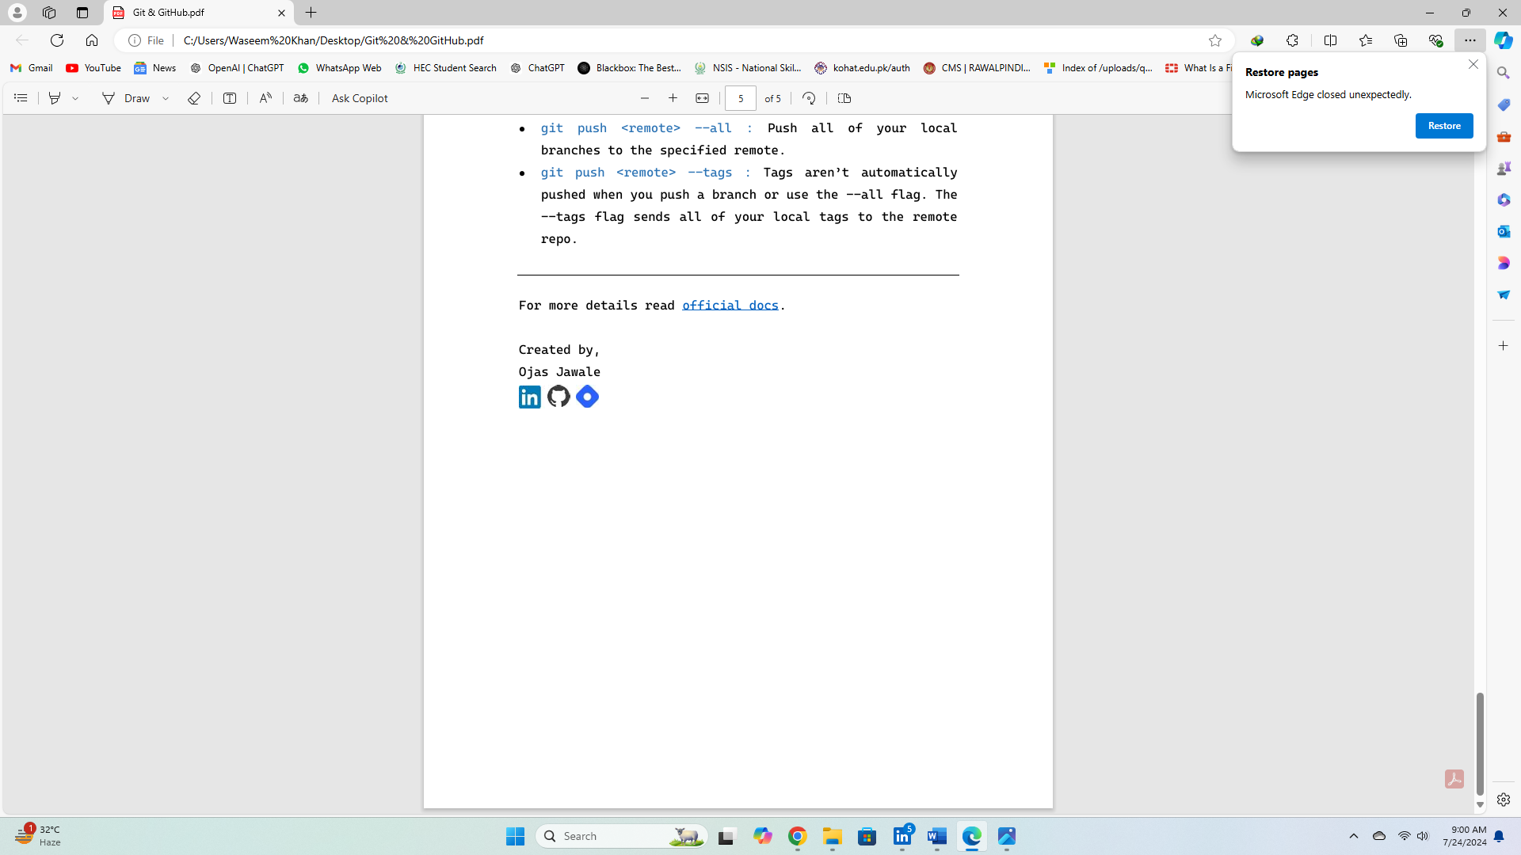

**Waseem Khan**

Linux

Basics (01)

Uses

Linux are used by smart phones, Super Computers, Smart Watches/TVS

Smart Phone:

Advantages of Using Linux:

Free and Open Source, Performance is too Good, Multi User Based, Multi-Tasking, Security.

Two Modes of Linux:

Summary

* GUI is user-friendly, while CLI requires command knowledge.
* GUI uses more resources; CLI is lightweight.
* CLI is generally faster and more efficient for complex tasks.
* CLI offers more control and flexibility.
* CLI excels in automation.
* CLI is more customizable.
* CLI is easier for remote access.
* GUI is better for simple tasks; CLI is ideal for complex tasks.
* CLI is more useful for system recovery.

GUI is great for everyday tasks and beginners, while CLI is powerful for advanced users, system administrators, and those needing precise control and automation.

Linux Commands:

1.Command use to go from ec2 to Root User:

* sudo -i

Alternative:

* sudo su –
* sudo su

Why we use this command:

In Linux, the root user has complete control over the system, while regular users, like the EC2 user, have limited permissions. Working as root can be necessary for certain administrative tasks, but it also comes with risks. Here’s a detailed explanation of when and why you might work as root versus using a regular user account, especially in environments like AWS EC2.

2.Command use to go from Root to ec2 user:

* logout

Alternative:

* exit
* ctrl + d

3.Command to Check CPU information:

Basically, CPU information stored in a file called ‘cpuinfo’ which is located in a folder ‘proc’. to show the content of a file we use ‘cat’ command with the above file and folder name.

* cat /proc/cpuinfo

Alternative:

* lscpu

4.Command to Check Memory (RAM) Information:

Basically, Memory information stored in a file called ‘meminfo’ which is located in a folder ‘proc’. to show the content of a file we use ‘cat’ command with the above file and folder name.

* cat /proc/meminfo

Alternative:

* lsmem

4.Command to Check Memory (RoM/Volume) Information:

* fdisk -l

alternative:

* lsblk
* df
* df -m
* df -i

5.Command to check ip address of a own server:

* ifconfig

alternative:

* ip addr
* ip addr show
* host name -i Preferred Command

**Created By,**

**Waseem Khan**